DATE …………………….……… STUDENT NO……...……………...…………..…

EXAMINATION CENTRE ……...………………………………………………….…………..

THE SHIPPING AND FORWADING AGENTS’ ASSOCIATION OF ZIMBABWE



## FREIGHT FORWARDING PRACTICE DIPLOMA COURSE

**FINAL EXAMINATION**

**PAPER TWO**

# GENERAL PAPER

**28 NOVEMBER 2019**

**TIME ALLOCATION: (3 HOURS)**

**INSTRUCTIONS**

* Answer **FOUR** questions. Question **ONE** is compulsory
* Your student number must appear on all your answer sheets.
* This examination script is the property of SFAAZ and must not be removed from the examination room.
* This paper carries 60% of the final examination marks.
* Answer a new question on a fresh sheet of paper.

**FFP NOVEMBER 2019 Final / P2**

**Case Study**

[KMTC HongKong](https://shippingandfreightresource.com/kmtc-container-ship-on-fire-thailand/) a container ship caught fire at Laem Chabang, Thailand on the 25th of May 2019.. It was reported that 35 containers were on board when the ship caught fire..

Port Authority director Kamolsak Phromprayoon has been quoted as saying that “*after a lot of efforts, the port officers successfully put out the fire late on Saturday.*“..

The investigation team which was sent to inspect the damage on the KMTC Hongkong on Sunday found Calcium Hypochlorite in 13 containers and Chlorinated Paraffin Wax in 5 other containers and concluded that the ignition of these toxic chemicals is the most plausible cause of fire..

The Nation has [reported](http://www.nationmultimedia.com/detail/national/30370019) that the Thailand Port Authority has disclosed that the hazardous goods on board the KMTC HongKong were not declared and that some of the containers were said to contain Dolls..!!

Source; Shipping and Freight Resouce – 27 May 2019

**Required**

**1.**

1. Explain in detail what could have led to the fire outbreak and discuss what should have happened to avoid this disaster. **(8 marks)**
2. What is the vessel type and what sort of service does the operator offer?

**(5 marks)**

1. Explain why the VOCC did not pick up the correct container contents from the set of supplied documents. **(3 marks)**

**2.**

1. Explain the environmental impact of the incident in the case study. In your explanation highlight the regulators that will be interested in this incident. **(8 marks)**
2. Explain which protocol has been breached in the case.  **(2marks)**
3. Explain the insurance principles that apply to this case. Answers should be related to examples in the case. **(8 marks)**
4. What role would the ICS, CSI programme and CDI program play in this case?

**(6 marks)**

**(TOTAL CASE STUDY 40 MARKS)**

**FFP NOVEMBER 2019 Final / P2**

**Question Two**

1. A freight forwarder serves as a channel for global trade between importers, exporters, the transportation and regulatory entities such as shipping lines, customs, port etc. The moment a freight forwarder signs/accepts a contract (although discouraged, remember that a contract may also be verbal) with the customer, they are exposed to several unique risks and liabilities.

Explain in detail using practical examples 5 major risks or liabilities that a freight forwarder is exposed to once they have been contracted by a customer when undertaking a contract for the transportation of cargo from point to point. **(15 marks)**

1. A fellow freight forwarder asks you this question “How do I know the bill of lading issued is House Bill of Lading or Master Bill of Lading?” In your response clearly indicate the differences between the two documents and the parties that are involved. **(5 marks)**

**(TOTAL 20 MARKS)**

**QUESTION 3**

1. Your transport company which is based in South Africa has just won a one year contract to move 5000 cartons (each weighs 15 kgs and measures 20cm x 20cm x 20cm) of standardized components to be welded into the electrical board of photocopier machines assembled in Hong Kong. The first shipment is expected to be moved in three months’ time.

**Describe and justify the process involved in moving this shipment. (12 marks)**

1. Between air and sea transportation, discuss which service characteristics would affect your decision on which is the preferred mode of transportation. **(8 marks)**

**(TOTAL 20 MARKS)**

**FFP NOVEMBER 2019 Final / P2**

**QUESTION 4**

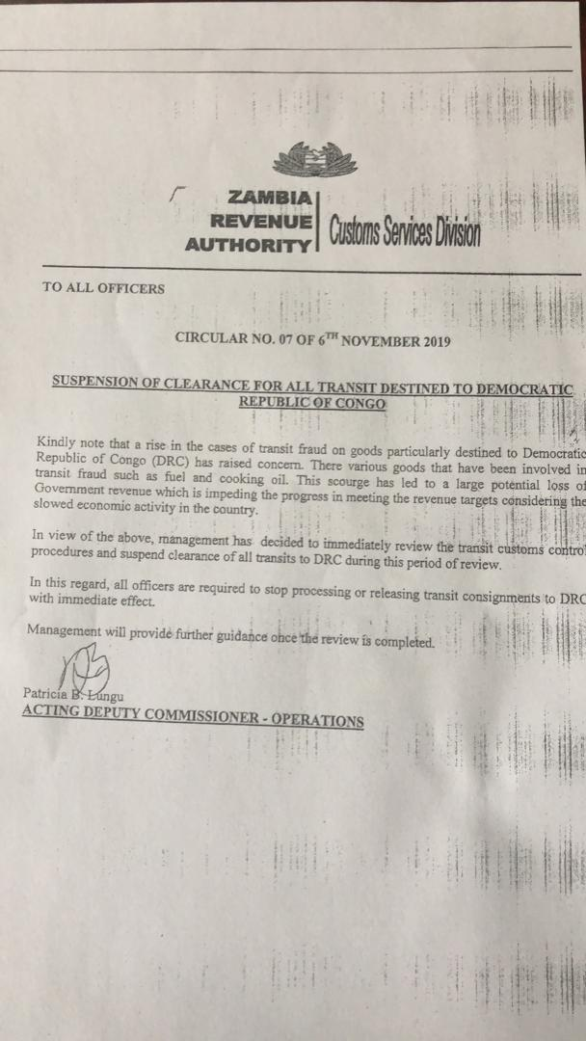

1. What effect will the above notification from ZRA have on the traffic coming from South Africa and traffic coming from Zimbabwe? In your answer clearly outline the risks associated with such a development. **(10 marks)**
2. As a freight forwarder what possible contingent plans would you put into action to mitigate the negative effects that will result from this development? **(4 marks)**
3. How best can companies and governments contribute towards reduction of risks in supply chains? **(6 marks)**

**(TOTAL 20 MARKS)**

**FFP NOVEMBER 2019 Final / P2**

**QUESTION 5**

1. How can freight forwarders remain relevant in fast changing supply chains?

**(16 marks)**

1. **According to the Herald Newspaper issue of 27 July 2019,** President Mnangagwa opened Zimbabwe’s dry port facility at Walvis Bay, Namibia.

What is a dry port and how does Zimbabwe benefit from such an investment?

**(4 marks)**

**(TOTAL 20 MARKS)**